* Kids Yoga *

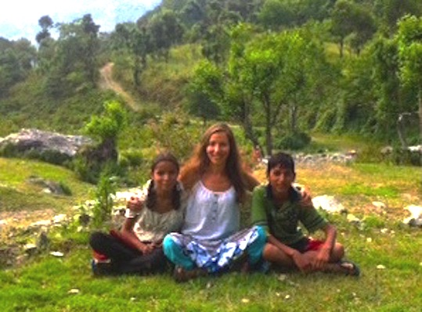
Benefits of yoga for children
- Develop body awareness and learn how to use their bodies in a healthy way
- Manage stress through breathing, awareness and healthy movements
- Build concentration and mental strength that would help them in their studies
- Increase their confidence, patience, positive self-image and compassion that would improve their social life

About Marina
Marina is a qualified yoga & meditation teacher who’s been involved in various kids’ projects since 2007. She has relevant experience working in Europe (England & Poland) as well as volunteering in Asia (India & Nepal).
Marina genuinely believes in the benefits of yoga & meditation. She sees her mission to bring this experience to as many kids as possible to help them grow healthier and happier human beings.

Kids Yoga Lesson template
Postures (about 30min)
Kids are encouraged to do physical activities (mainly strengthening and stretching exercises) in a playful manner. Most postures are related to animal (dog, cat etc.) or nature objects (tree, volcano etc.), which usually are enthusiastically performed by kids. They can be taken on an adventure to the zoo, jungle or somewhere else using storytelling, visual objects (books or printed animal cards) and simply their imagination.
Breathing & Relaxation (about 10 min)
Kids are encouraged to follow various breathing techniques, e.g. for relaxation (full breathe), for releasing anger & emotions (lion breathe) etc. At the end of the session calm music is played while children are either lying down or sitting calmly. During this part they are encouraged to relax their bodies and minds. Additional relaxation techniques might be used like: visualisation story telling/ gentle body touching/ playing calming musical instruments like bells etc.

