“YOGA at WORK”
with Marina
2017

* * *
MESSAGE
“As you are well aware, in recent years life-pace has increased dramatically; coping with it has become even harder. I think everyone would agree that humanity is facing an important task of learning how to rest and re-energise. It is especially crucial for modern workers who have to cope with a lot of stress while having a shortage of time to recover. I understand this problem very well with years of personal experience working in a demanding corporate environment and facing such situations regularly.
I was questioning how I could manage stress better and be more productive performing my regular tasks.
My solution to it has been Yoga and Meditation practices through which I gained mental and physical strengths.
It increased my stamina, equipped me to deal with stress and generally helped have a positive outlook. Deeper understanding came to me when learning directly from Masters of these ancient philosophies in India & Nepal.
I have a strong call to share my experience and knowledge with other people who are looking for a way to control and minimise their stress and live a more full and balanced life. I have chosen to do everything in my capacity to help these people.”
* * *
PROGRAMME classical “Hatha Yoga” or its variation “ Chair Yoga”, 60 minutes
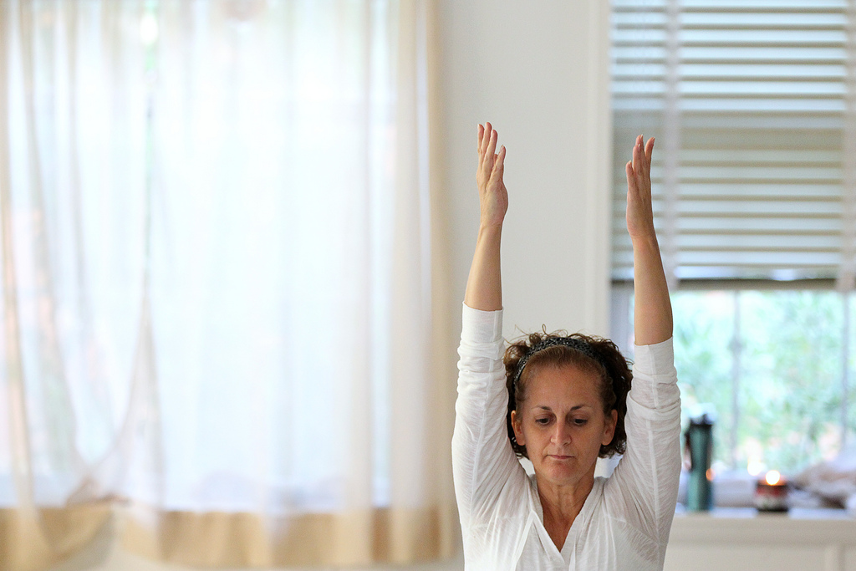
There are many types of Yoga and many of them have appeared in recent years. Hatha Yoga is valued for being a classical example of Yoga.
Hatha Yoga is a great ancient wisdom system, mind-body-spirit practice that combines stretching and strengthening exercises, controlled breathing, relaxation and meditation techniques.
It has a number of health benefits and almost everyone can do it!
If there is no room to roll out a yoga mat, it is not a problem.
We can practice Chair Yoga!
AIM of the workshop:
- To give techniques of performing breathing and physical exercises as well as basic meditation practices
- To show through theory and practice how yoga can increase physical & emotional stamina, improve focus & concentration and reduce stress; therefore improve individual and corporate performance

* * *
ABOUT MARINA
Holistic, well-being therapies & teaching
MARINA
E d u c a t i o n
Yoga & holistic studies in Europe – Yoga courses Level 1- 6 (Sivananda, London 2009-2012), Well Woman Yoga (Womb Yoga, London 2013), Yoga for Kids (Yoga Beez, London, 2013) Yoga Anatomy (Sivananda, London 2014), Bach Flowers I, II (Nelsons, London 2013)
Yoga studies in India – TTC in Hatha Yoga (Siddhartha Yoga Centre, Bhagsu, India 2014)
Thai massages and natural therapies – Old Medicine Hospital, Chiang Mai, Thailand 2014
Ayurvedic studies: philosophy, main principles and therapies, oil massage – AyuSkama, McLeod Ganj, India 2014
Sound Therapy with Tibetan singing Bowl – Sound Planetarium, Kathmandu, Nepal 2014
Reiki Level 1, 2 – private course with a teacher, Pokhara, Nepal 2015
W o r k e x p e r i e n c e
Corporate wellbeing Workshop – Meditation and Relaxation programme, London 2015 -2016
Yoga Workshops – Introduction to Yoga and Meditation, Bieszczady, Poland 2015 (GD festival)
Yoga Teaching – Hatha yoga, pranayama and meditation in classical tradition, McLeod Ganj, India and Pokhara, Nepal 2014-2015, Massage and Sound Therapies with Tibetan singing bowls – Rishikesh, India and Pokhara, Nepal 2014 – 2015

Phone: +44 7989 778017
Email: mermina@hotmail.co.uk
Website: http://dawmar.weebly.com/

