Meditation & Relaxation
with GONG & SINGING BOWLS
- Sound Therapy -
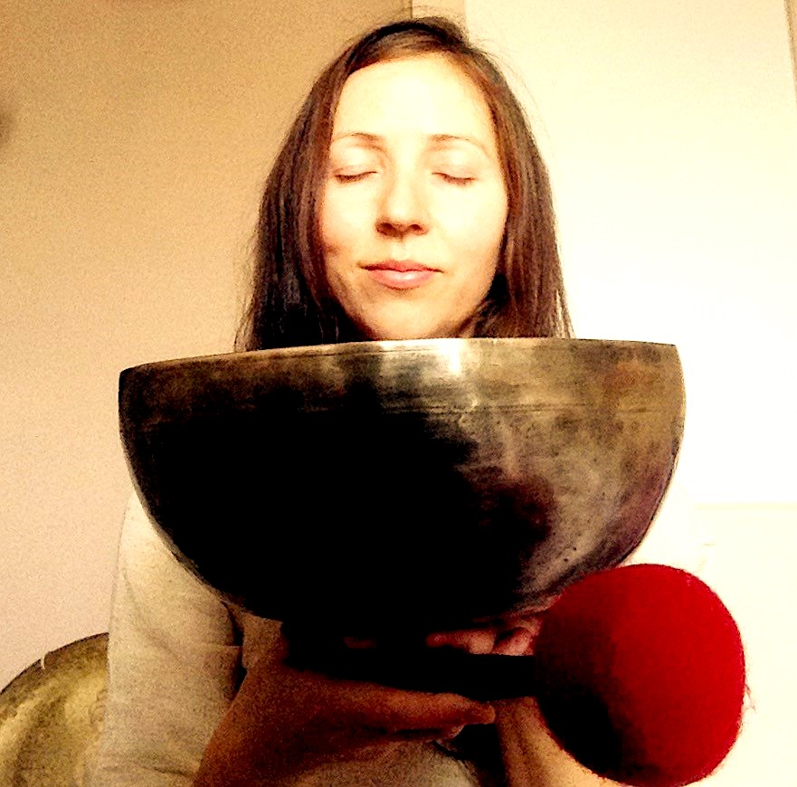
Marina was born in Russia but sees herself as a person of the world. She was traveling and living in different parts of Europe and Asia. On her journey Marina was studying and practicing holistic therapies like yoga, sound therapy, Ayurvedic science and massages. Since she discovered Tibetan singing bowls in Nepal, she has seen her mission in bringing these positive vibrations to the whole world to make it a better and more loving place.

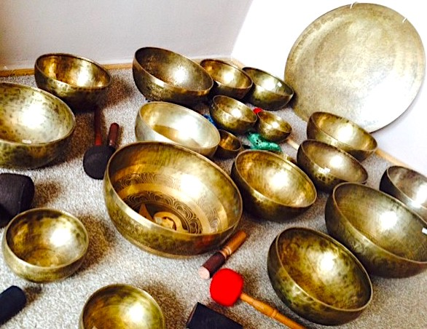
Tibetan Singing Bowls originated eighteen thousand years ago. Traditionally they are hand-made from the alloy of elements which symbolize energy of some of the planets in our Solar System. They have been used for centuries for healing and transformation of consciousness.
When played, Tibetan Singing Bowls vibrate and produce a deep, rich tone. In alternative medicine, many proponents claim that these vibrations can produce beneficial changes within the body by reducing stress, harmonizing the cells, and balancing the body's energy system. Some also claim that Tibetan Singing Bowls can stimulate the immune system and produce beneficial changes in brain waves.

Inviting warmly to experience this beautiful anceint practice!

Place & Time: to be advised
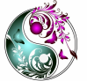
Due to limited availability, please book in advance:
mermina@hotmail.co.uk/
www.dawmar.weebly.com
(Marina speaks English and basic Polish)

