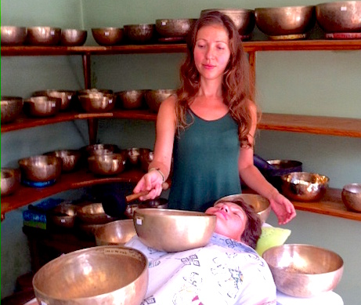
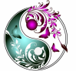

DAWMAR / WELLBEING

SOUND THERAPY/ with Singing Bowls
BODY MASSAGE/ on tensed parts
INTUITIVE energy healing
60 min
TREATMENT
with Tibetan Singing Bowls
Balancing on physical, mental and emotional levels
- Holistic massage (through clothes)
- Relaxation with Singing bowls
- Intuitive Energy healing
About practice:
During the treatment Marina uses Tibetan Singing bowls, individually blended aroma oils and her hands & heart. Tibetan Singing bowls are type of bells shaped like bowls that produce a magnificent sound. They are excellent for reducing stress, achieving deep relaxation as well as energy balancing & overall holistic healing.
About Marina:
Marina is a qualified and experienced body worker specializing in Thai Massage, Ayurvedic Massage & Sound therapy with Tibetan Singing bowls. She had successful practice in private clinics of India & Nepal (2014/15) and Europe /UK London, Poland Rzeszow (2016/17). In her practice Marina pays attention to the whole wellbeing of the person. She is very gentle and intuitive in her approach to people.
Testimonial:
“Marina is incredibly warm and trustworthy person. She works with amazing attentiveness, focus and love. Thus, she can quickly detect what it is that a person needs most at that particular moment of her/his life. After the session I experienced lasting increase of vitality, inner harmony and peace, deep relaxation, clarity of mind, strength to make an important decision as well as a feeling of security and self love” Shoshana Bozia

Contact details: mermina@hotmail.co.uk / 737 611 288 Poland
Languages: Marina speaks English, Russian & basic Polish
* advance bookings are required *

60 min - individual session

mermina@hotmail.co.uk
follow special events & updates @ www.dawmar.weebly.com

